


2024 Adult Inpatient
Survey

Statistical Release

NHS Patient Survey Programme

Independent analysis for England
Published: September 2025
Contents
1. Summary of findings 2
How experience varies for different groups of people 3
1.1. Positive findings 3
1.1.1. Overall experience 3
1.1.2. Staff availability 3
1.1.3. Interactions with hospital staff 4
1.1.4. Discharge 4
1.2. Areas for improvement 4
1.2.1. Accessing care 4
1.2.2. Post-discharge care 4
2. About the Adult Inpatient Survey 5
3. Results from the survey 6
3.1. Differences in patient experience 7
3.2. Overall experience 8
3.3. Admission to hospital 10
3.4. Care and treatment 12
3.5. Discharge from hospital and integrated care 19
3.6. Subgroup analysis 22
4. Inpatient care policy 28
Appendix A: Survey methodology 34
Appendix B: Other sources of information related to survey results 39
Appendix C: Comparisons with other data 41
Appendix D: Main uses of the survey data 42
Appendix E: Revisions and corrections 44
Appendix F: Further information and feedback 45
Accredited Official Statistics status 46
Appendix G: ICD-10 chapter codes 47
References 48

1. Summary of findings

The Adult Inpatient Survey seeks feedback from people who stayed in hospital for at least one night for tests, medical treatment or surgery during November 2024. Patients are admitted to inpatient services for planned elective care, or as the result of an emergency admission. A total of 131 NHS trusts in England took part in the survey for 2024, with 62,444 (41%) service users responding. All data was collected between January and April 2025.

Results from the 2024 survey show some areas of improvement when compared to those from 2023. Of the 36 questions that were also asked in 2023, 17 show statistically significant improvement, 17 remain stable and 2 show statistically significant decline. Although results are still poor for many of areas of care – and continue to be worse than those reported in 2020 – this year’s survey indicates early signs of improvement in how people experience acute adult inpatient services.

In particular, results show improvement in the availability of staff, with 57.9% of people reporting there were ‘always’ enough nurses on duty to care for them, compared to 55.7% in 2023 and 51.6% in 2022. Similarly, questions about people’s interactions with hospital staff have also shown improvement, as have most questions about discharge from hospital.

Conversely, access to inpatient care continues to be particularly challenging. The survey results for 2024 show that 2 in 5 (42.1%) elective patients would like to have been admitted to hospital sooner, while a similar number (42.9%) reported their health deteriorated while they waited to be admitted.

This year’s results also found that although 79% of patients had conversations with staff about their health or social care needs after leaving hospital, almost a quarter of respondents (23.1%) did not get enough support from health or social care services to help them recover or manage their condition.

How experience varies for different groups of people

Respondents with a disability or those living with frailty reported poorer experiences of inpatient care for all 18 questions included in our subgroup analysis.

Respondents with dementia, Alzheimer’s disease, a mental health condition, a neurological condition, or a condition that affects their physical mobility, all reported poorer experiences in most areas, such as being able to get help when they needed it and being able to discuss their fears and worries with staff.

1.1. Positive findings

1.1.1. Overall experience

Just over half (52.1%) of the respondents rated their overall experience of inpatient care highly, with scores of 9 or 10 out of 10 – a significant increase compared with the 50.8% of total respondents who scored their experience similarly in 2023 and 50.2% in 2022. Those who gave scores of 0 or 1, indicating that they had a very poor experience, remains low, at 3.4%, compared to 3.6% in 2023.

1.1.2. Staff availability

The proportion of respondents who felt that there were ‘always’ enough nurses on duty (57.9%) has risen by 2.2 percentage points – a statistically significant change from 2023 (55.7%), having previously fallen to 51.6% in 2022.

Most respondents said that they were able to get a member of staff to help them when they needed attention to some extent with 64.5% reporting that this was ‘always’ the case, and 33.1% ‘sometimes’, a significant increase compared to 63.1% and 34.2%, respectively.

1.1.3. Interactions with hospital staff

More than 4 in 5 (82.2%) respondents felt that they were ‘always’ treated with respect and dignity while in hospital, with 79.9% of all respondents feeling that they were 'always' treated with kindness and compassion.

Three-quarters of respondents ‘always’ felt included in conversations about their care by both doctors (76.2%) and nurses (76.8%). This represents a statistically significant increase in the proportion of respondents who ‘always’ felt included in conversations about their care – by doctors and by nurses – compared with 2023 (doctors: 74.7%; nurses: 75.1%).

The proportion of respondents who said staff involved them ‘a great deal’ in decisions about their care and treatment (36.8%) has increased significantly when compared with the proportion of respondents who felt similarly in 2023 (34.7%).

1.1.4. Discharge

Results show statistically significant improvement across most questions related to discharge from hospital. For instance, 72% of respondents were either involved in decisions about leaving hospital either ‘a great deal’ (34.3%) or ‘a fair amount’ (37.7%) compared to 71% in 2023 (33.2% and 38.1% respectively). Similarly, 73.7% of respondents said they were told who to contact if they were worried about their condition after leaving hospital, compared to 72.5% in 2023.

1.2. Areas for improvement

1.2.1. Accessing care

Two in 5 (42.1%) elective patients said that they would like to have been admitted sooner (22.2%) ‘a bit sooner’ and 19.9% ‘a lot sooner’.

Two in 5 (42.9%) elective patients said their health deteriorated while waiting to be admitted to hospital (25.2%, ‘a bit worse’; 17.7%, ‘much worse’).

The proportion of respondents who felt that they had waited ‘a bit too long’ (15.4%) or ‘far too long’ (17.8%) to get a bed after arriving at hospital has changed little since 2023 (15.1% and 17.8%, respectively). Analysis conducted on the most positive response option indicates a downward trend for this question since 2020.

This year, respondents were also asked how long they had to wait before they were admitted onto a ward. A quarter (25.5%) of patients who had to wait to be admitted onto a ward did so for 6 hours or more, while 17.5% waited for 12 hours or more, and 9.8% for more than 24 hours.

1.2.2. Post-discharge care

One in 5 (19.9%) respondents said that hospital staff did not discuss whether they would need any additional equipment or changes to their home after leaving the hospital but would have liked them to. Analysis also indicates a downward trend in the most positive response option for this question since 2020.

Less than half (47.5%) of respondents felt they ‘definitely’ got enough support from health or social care services to help them manage their condition after leaving hospital, and 23.1% said they did not receive enough support.

2. About the Adult Inpatient Survey

The Adult Inpatient Survey has been conducted annually since 2002. In 2020, it transitioned from an entirely paper-based survey to a mixed-mode data collection method (so has since been available as an online survey and a paper questionnaire). This change in methodology affected the way in which patients responded to the survey questions, meaning that the results from surveys conducted before 2020 are not comparable with the results from surveys conducted in 2020 and later.

This statistical release presents the key results from the 2024 survey and statistically significant differences when compared with the results of previous iterations of the survey, dating back to 2020. Results for all questions patients were asked are published on the Care Quality Commission’s website.

A total of 131 NHS trusts that deliver adult inpatient services in England participated in the 2024 survey.

- Eligibility: all patients aged 16 years or over at the time of their hospital stay were eligible to take part if they had spent at least 1 night in hospital, were not admitted to maternity or psychiatric units, and were discharged from the trust during November 2024.

- Fieldwork: fieldwork took place between January and April 2025.

- Response rate: a total of 62,444 people responded to the survey, representing a response rate of 40.8%. This large sample size gives us confidence that these results are representative of the experience for inpatients in England.

The importance of collecting patient experience data

People’s experiences provide important insight about the quality of healthcare services across England. In CQC’s most recent Public Engagement Strategy, 1 of the 4 strategic objectives outlined is to build a trusted feedback service where people’s experiences drive improvements in care.

The NHS Constitution commits the NHS to welcoming feedback from patients about the care they received, so that feedback can be used for the continuous improvement of services. Domain 4 of the NHS Outcomes Framework recognises the importance of patient experience in delivering a high-quality service.

All questionnaires in the NHS Patient Survey Programme are designed to reflect themes from the NHS Patient Experience Framework. The framework identifies several elements that contribute to a person’s positive experience of NHS care:
- Respect for patient-centred values, preferences, and expressed needs, such as shared decision making and cultural issues.
- Welcoming the involvement of friends, family, and people who are close to the patient
- Emotional support.
- Access to care, with attention given to waiting times.
- Coordination and integration of care across the health and social care system.

Research has found that positive experiences of using healthcare services are beneficial for both people who use services and providers. For people who use services, positive experiences are linked to better health outcomes. For providers of services, good experiences for people can lead to lower costs of care and improved organisational reputation.

3. Results from the survey

This section presents key results for the 2024 Adult Inpatient Survey.

The survey sampled patients who had stayed in hospital for at least 1 night in November 2024. It followed people’s journeys from admission to hospital, treatment, and discharge. Not all findings or response options are reported here, though the full set of results for all questions can be found on the Care Quality Commission’s (CQC) website.

The 2024 results have been compared with those from the 2023, 2022, 2021, and 2020 surveys to identify trends over time. Where possible, statistically significant differences have been highlighted with asterisks.

In addition to trend analysis, a multivariable analysis (‘subgroup analysis’) was conducted on the results, to compare how different subgroups of patients rated their care. Additional findings from this analysis are presented throughout the report and discussed at the start of the ‘Difference in patient experience’ section. Further information on this analysis can be found in the ‘subgroup analysis’ section.

The main policy, standards, and guidelines relating to the care of adults admitted to hospital as inpatients in England are discussed in the ‘Inpatient care policy’ section and throughout the report, where relevant.

Survey results are discussed under the following key themes:

- Differences in patient experience
- Overall experience
- Admission to hospital
- Care and treatment
- Discharge from hospital and integrated care
- Subgroup analysis

3.1. Differences in patient experience

Across the survey, people with a disability, a physical or mental health condition or dementia report poorer inpatient experiences for most of the questions analysed. People who had an emergency admission to hospital also had poorer experiences than those with planned admissions.

Respondents with a disability or those living with frailty reported poorer experiences of inpatient care for all 18 questions included in our subgroup analysis.

Respondents who had an emergency admission were more likely to report a poorer experience for 16 of the 17 questions analysed, with the exception being getting enough support from health or social care services after they left hospital. Similarly, those who had dementia or Alzheimer’s disease also reported poorer experiences for 16 of the questions analysed, with the exception of staff discussing further support from these services.

Respondents who had a mental health condition, a neurological condition, or a condition that affects their physical mobility were more likely to report a poorer experience in more than half the questions analysed, including:
- confidence and trust in doctors and nurses
- feeling able to discuss their fears and worries with staff
- being treated with respect and dignity
- overall experience.

Those with a physical mobility condition were also more likely to report a poorer experience in the following areas:
- getting enough help to wash, to eat, or manage their pain
- being able to get help when they needed it
- being able to take medicine they brought with them to hospital
- getting consistent information from hospital staff
- being treated with kindness and compassion.

Respondents with a mental health condition also reported poorer-than-average experiences of staff discussing any further support needs from health or social care services and getting enough support from those services after they left hospital, as well as being able to take medicine they brought with them to hospital, getting enough help to manage their pain, and being treated with kindness and compassion.

Those with a neurological condition were also more likely to report poorer experiences of getting enough help to wash or eat, being able to get help from staff when they needed it, getting enough to drink, and getting consistent information from hospital staff.

3.2. Overall experience

As in previous years, respondents were asked to provide a score for their overall experience of receiving inpatient care, ranging from ‘0 – I had a very poor experience’ to ‘10 – I had a very good experience’.

Over half (52.1%) of the respondents gave high scores of 9 or 10 – a significant increase compared with 2023 (50.8%). Those who gave scores of 0 or 1, indicating that they had a very poor experience, remains low, at 3.4% (figure 1).

In addition to the subgroups discussed in the section above, those more likely to report a worse overall experience included respondents aged 16 to 50, autistic people, and people with the following long-term conditions: blindness or partial sight, deafness or hearing loss, or ‘another long-term condition’. This was also true for respondents whose treatment type was a medical (non-surgical) case.

Figure 1: Q48. Overall, how was your experience while you were in the hospital?
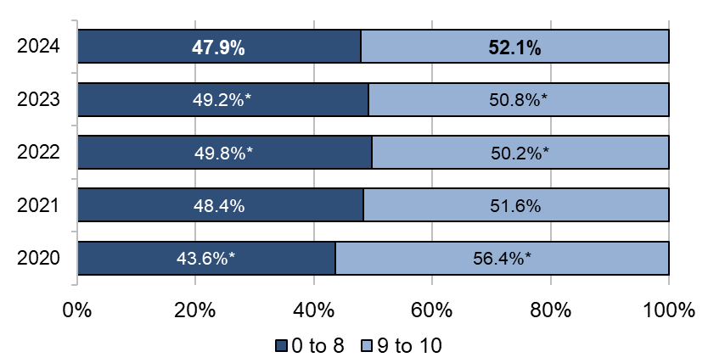

Response data for question 48 aggregated into 2 distinct groups.
An asterisk indicates a statistically significant difference when compared to the 2024 results.
Answered by all.
Total number of respondents: 71,677 (2020), 60,805 (2021), 61,327 (2022), 62,003 (2023), 60,980 (2024)

Respondents from the least deprived areas of England, as indicated by being categorised into the 8th, 9th, and 10th deciles within the Index of Multiple Deprivation (IMD), were also more likely to report a worse overall experience.

Among the respondents who were more likely to report a better overall experience were those:
- who were male
- who were aged over 50
- who identified as heterosexual
- who identified as Christian
- who had had an elective admission
- whose treatment type was a surgical case
- from the most deprived areas of England (specifically, in the 1st and 2nd IMD deciles).

3.3. Admission to hospital

3.3.1. Waiting lists

Lord Darzi's report on the state of the National Health Service in England highlights that in almost all NHS services, performance on access to care has declined. The maximum waiting time for non-urgent, consultant-led treatments is 18 weeks from the day an appointment is booked through the NHS e-Referral Service, or when the hospital or service receives a referral letter. For urgent referrals the maximum waiting time target is 2 weeks. The 10 Year Health Plan for England commits to restoring the NHS constitutional standard of 92% of patients beginning elective treatment within 18 weeks.

Figure 2 shows that 2 in 5 elective patients would have liked to have been admitted to hospital sooner (22.2%, ‘a bit sooner’; 19.9%, ‘a lot sooner’), with a similar proportion of elective patients saying that their health deteriorated to some extent while waiting to be admitted to hospital (25.2%, ‘a bit worse’; 17.7% ‘much worse’).

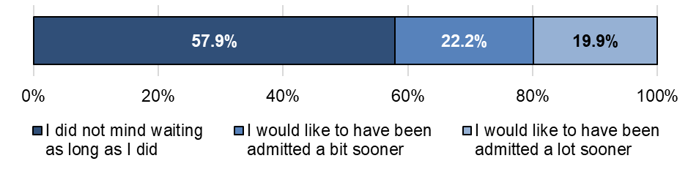
Figure 2: Q2. How did you feel about the length of time you were on the waiting list before your admission to hospital?
Answered by respondents whose most recent hospital admission was through a waiting list or was pre-planned.
Total number of respondents: 15,583 (2024)
Half (49.8%) of the elective patients rated the quality of information they were given while they were on the waiting list as ‘very good’, with a further quarter (24.8%) rating it as ‘fairly good’.

We compared how respondents felt about being on a waiting list with how they rated the quality of information they received while on the waiting list – this helped us to gain insight into some common themes. Of those respondents who said that they would have liked to have been admitted ‘a lot sooner’, nearly a third rated the information they had received as poor (13.9% ‘very’ poor; 17.3% ‘fairly’ poor), with a further 8.9% saying that they were not given any information at all. Most respondents who said that they did not mind waiting rated the quality of information they had received while on the waiting list as good (67.5% ‘very’ good; 21.6% ‘fairly’ good).

3.3.2. Admission to a ward

The Royal College of Physicians’ statement for a ‘zero tolerance’ approach to corridor care sets out practical recommendations for hospitals and local healthcare systems to manage corridor care, including regular reviews of the demand for inpatient care, developing robust plans to expand inpatient capacity, working with system partners and patients to ensure timely discharge or transfer from acute settings, and providing operational support to clinicians to ensure timely interventions that maximise patient flow.

Figure 3 shows that the proportion of respondents who felt that they waited ‘a bit too long’ (15.4%) or ‘far too long’ (17.8%) to get a bed after arriving at hospital has changed little since 2023 (15.1% and 17.8%, respectively). Analysis conducted on the most positive response option indicates a downward trend for this question since 2020.

In addition to those groups discussed at the start of this results section, respondents who reported poorer-than-average experiences of waiting to get a bed after arriving at hospital were those who received medical (non-surgical) treatment, as well as people aged 16 to 35, those with a heart problem, or ‘another long-term condition’.
For the 2024 survey, respondents who said that they had to wait before being admitted onto a ward were asked where they were requested to wait. The most common locations reported were either a treatment bay (45.6%), a waiting room (30.8%), a corridor, or a hallway (18%).

A quarter (25.5%) of the patients who had to wait to be admitted onto a ward did so for between 6 and 12 hours, with a further 17.5% reporting waiting for 12 hours or more, and a further 9.8% for more than 24 hours.

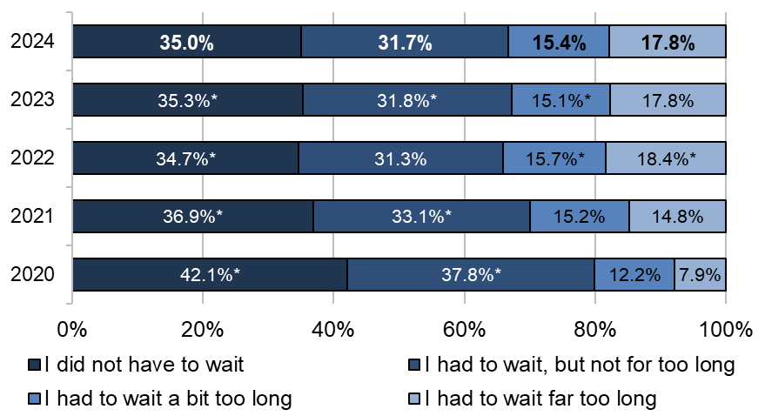
Figure 3: Q5. How long do you feel you had to wait to get to a bed on a ward, after you arrived at the hospital?

An asterisk indicates a statistically significant difference when compared to the 2024 results.
Answered by all.
Total number of respondents: 72,102 (2020), 61,224 (2021), 61,524 (2022), 62,273 (2023), 59,319 (2024)

3.4. Care and treatment

3.4.1. Person-centred care

The Health Foundation’s definition of person-centred care is underpinned by 4 principles: personalised care, coordinated care, enabling care, and dignity, compassion and respect.

Patients have the right to be treated with respect and dignity, as stated in the NHS Constitution. This is also reflected in the National Institute of Health and Care Excellence’s (NICE) quality statement 1, which states that patients should be treated with empathy, respect, and dignity – these being fundamental to developing good patient and staff relationships.

The proportion of respondents who felt that they were 'always' treated with respect and dignity remains high (82.2%). However, analysis of the most positive response option indicated no significant trend since 2020 for this question. Similarly, 4 in 5 (79.9%) respondents felt that they were ‘always’ treated with kindness and compassion while in hospital, consistent with the proportion who said the same in 2023 (80%).

Respondents who were less likely to feel that they had been treated with either respect and dignity, or kindness and compassion were people aged 16 to 50, those who had had an emergency admission, indicators of frailty, a disability, or a long-term condition, including:

Respondents with a neurological condition were also less likely to feel they had been treated with respect and dignity.

Supporting patients to wash and maintain their levels of personal hygiene is an important factor in caring for patients with respect and dignity. Seventy per cent of respondents were ‘always’ given enough help from staff to keep themselves clean, which is in line with results from 2023. One in 10 (10.5%) respondents reported ‘never’ getting enough help to wash or keep themselves clean, compared with 7.6% in 2020. Our analysis of the most positive response option with regard to this question showed a downward trend since 2020.

In addition to subgroups discussed at the start of this results section, people who were more likely to report worse experiences with getting enough help to wash or keep themselves clean included those:
- aged 16 to 50
- whose treatment type was a medical case
- who were categorised into the 8th, 9th, and 10th (least deprived) IMD deciles
- diabetes or ‘another long-term condition’.

According to CQC’s regulation 14 ‘meeting nutritional and hydration needs’, healthcare professionals should prompt and encourage patients to eat and drink, and, where necessary, help them to do so.

Of the respondents who needed help from staff to eat their meals, 71% were ‘always’ able to get help, and a further 15% ‘sometimes’ got this help.

In addition to those discussed at the start of this results section, subgroups who also reported poorer-than-average experiences in this area include younger people (16 to 35), people aged over 80, those who had a hospital stay of 2 nights or more, those with deafness or hearing loss, the lasting day-to-day effects of a stroke or ‘another long-term condition’.

While the proportion of respondents who said that they got enough to drink remains high (87.1%), it is still lower than it was in 2020 (88.5%), with analysis indicating a downward trend of the most positive response option for this question.

Respondents were more likely to report worse experiences with getting enough to drink if they had a hospital stay of 1 night, or if their treatment type was a medical case – the same was true for those aged 16 to 50, or those with the lasting day-to-day effects of a stroke, or ‘another long-term condition’.

As outlined in guidance published by the Royal Pharmaceutical Society, patients are required, on admission, to give any medicines to nursing staff or a ward pharmacist for safe-keeping and administration during their inpatient care.

Figure 4 shows that the proportion of respondents who said that they were ‘always’ able to take medication they brought with them when they needed to, remains lower than it was in 2020 (70.2% compared with 74.9%), with analysis of the of the most positive response option for this question indicating a downward trend since 2020.

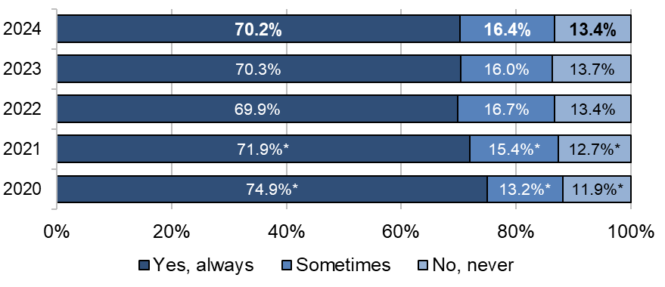
Figure 4: Q13. If you brought medication with you to hospital, were you able to take it when you needed to?
An asterisk indicates a statistically significant difference when compared to the 2024 results.
Answered by all. Respondents who stated that they had to stop taking medication as part of their treatment, or that they did not bring medication with them to hospital, have been excluded.
Total number of respondents: 40,294 (2020), 33,763 (2021), 33,806 (2022), 34,335 (2023), 33,907 (2024)

Among the respondents who were more likely to report worse experiences in this area were people aged 16 to 35, or aged over 80, those who had had a hospital stay of 2 nights or more, and those with the following long-term conditions:
- deafness or hearing loss
- the lasting day-to-day effects of a stroke
- ‘another long-term condition’.

The management of pain is a fundamental need for patients, with NICE’s quality statement 4 stating that staff should regularly check whether patients need any extra support with issues including pain relief.

Three-quarters (76.4%) of respondents said that staff ‘always’ did everything they could to help control their pain, compared with 76% who said the same in 2023. This has remained fairly consistent since 2022 (when 76.5% shared a similar experience). People were more likely to report bad experiences in this area when they were aged 16 to 50, diabetes, or ‘another long-term condition’.

Figure 5 shows that the proportion of respondents who felt that they were ‘always’ able to talk to hospital staff about their worries and fears (60.4%) has seen a statistically significant increase compared with the proportion of respondents who felt the same in 2023 (59.3%). Although lower than in 2020 (62.1%), as shown in figure 5, there has been a gradual improvement in experiences since 2022.

Figure 5: Q27. Did you feel able to talk to members of hospital staff about your worries and fears?
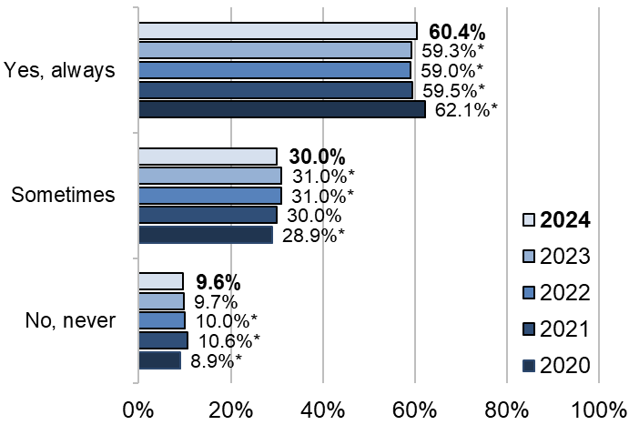

An asterisk indicates a statistically significant difference when compared to the 2024 results.
Answered by all. Respondents who stated they had no worries or fears have been excluded.
Total number of respondents: (2020) 60,972, (2021) 51,861, (2022) 52,373, (2023) 53,100, (2024) 52,742

In addition to those discussed at the start of this results section, the following respondent subgroups were more likely to report worse experiences of feeling able to talk to staff about their worries and fears:
- people aged 16 to 50
- female respondents
- people who had had a hospital stay of 2 nights or more
- people with kidney or liver disease
- those with ‘another long-term condition’.

3.4.2. Information and involvement in care

NICE guidance on improving patient experience in adult NHS services outlines the need for healthcare professionals to communicate information in a clear, accessible manner, avoiding jargon. Patients should be prepared for what to expect while in hospital and should be made fully aware of the benefits and any risks associated with a particular decision. The NHS Constitution pledges that people must be offered easily accessible, reliable, and relevant information in a form that they can understand, and that they should be supported to use it.

The proportion of respondents who felt that they were given the right amount of information about their condition or treatment remains consistent, at 77.8%, compared with 77.5% in 2023, with analysis indicating no significant trend in the most positive response option since 2020.

As shown in figure 6, a majority (61.2%) of respondents said they had never received conflicting information from different staff members, remaining mostly unchanged since 2022 (60.7% in 2023; 61.4% 2022), and remaining significantly lower than in 2020 (66.6% – see figure 6). Analysis conducted on the most positive response option for this question indicates a downward trend since 2020.

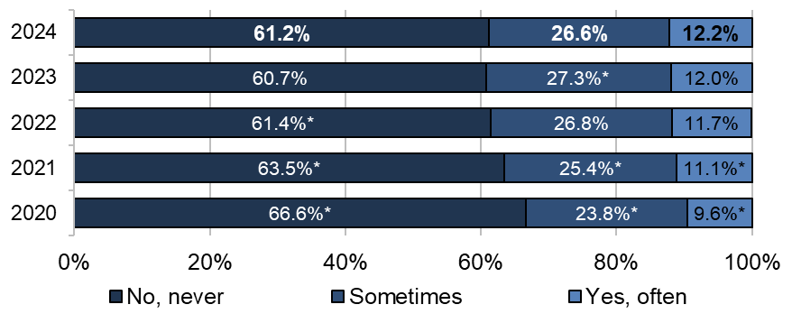
Figure 6: Q24. Thinking about your care and treatment, were you told something by a member of staff that was different to what you had been told by another member of staff?
An asterisk indicates a statistically significant difference when compared to the 2024 results.
Answered by all.
Total number of respondents: 64,430 (2020), 54,839 (2021), 55,320 (2022), 55,903 (2023), 55,057 (2024)

Among those respondent subgroups that were more likely to report worse experiences of getting consistent information from staff were people aged 16 to 50, those who identified as Asian or Asian British, patients who had had a hospital stay of 2 nights or more, and some groups with a long-term condition.

The NHS Constitution is clear that all patients have the right to be involved in their own care through decision making and planning, as well as a right to the information and support to do so.

In 2023, the Parliamentary and Health Service Ombudsman published Broken trust: making patient safety more than just a promise. This identified a small number of cases among recent complaint investigations where there were clinical consequences because of concerns from patients and families not being listened to.

A majority (4 in 5) of respondents felt that staff involved them in decisions about their care and treatment to some extent (43.8% were involved ‘a fair amount’; 36.8%, ‘a great deal’). The proportion of those feeling involved ‘a great deal’ has increased significantly compared with that in 2023 (34.7%), but remains lower than in it was 2020 (37.5%).

Respondents who had a hospital stay of 2 nights or more reported poorer-than-average experiences of involvement in their own care – as did people aged over 80, or respondents categorised into the 7th, 8th, 9th, and 10th (least deprived) IMD deciles.

Figure 7 shows that over three-quarters of all respondents ‘always’ felt included in conversations about their care by both doctors (76.2%) and nurses (76.8%). This represents a statistically significant increase for both doctors and nurses compared with respondents who felt the same in 2023 (doctors 74.7%; nurses 75.1%).

Figure 7: Q19/Q22. When doctors/nurses spoke about your care in front of you, were you included in the conversation?
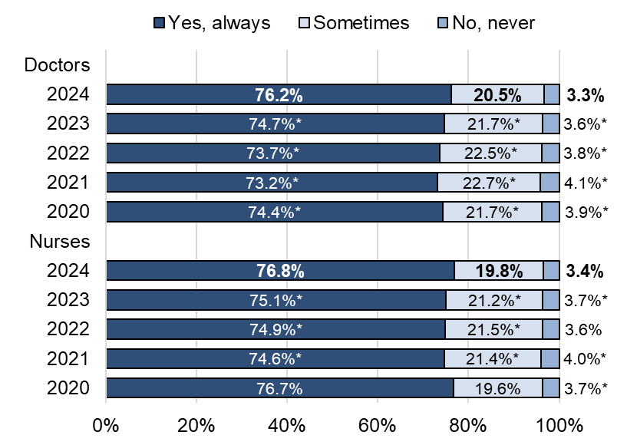

An asterisk indicates a statistically significant difference when compared to the 2024 results.
Answered by all.
Total number of respondents: Doctors 71,720 (2020), 60,966 (2021), 61,311 (2022), 62,061 (2023), 60,715 (2024). Nurses 71,669, (2020), 60,832 (2021), 61,183 (2022), 61,982 (2023), 60,587 (2024).

3.4.3. Hospital staff

Figure 8 shows that most respondents reported being able to get a member of staff to help them when they needed attention, to some extent (64.5%, ‘always’; 33.1%, ‘sometimes’). While the proportion of those who felt that they could ‘always’ get staff’s attention has increased significantly compared with that in 2023 (63.1%), it remains significantly lower than that in 2020 (66.9%).

As discussed at the start of this results section, several subgroups were more likely to have had poorer experiences in getting staff’s help when they needed attention. In addition to those discussed earlier, people aged 16 to 50, patients who had a hospital stay of 2 nights or more, and respondents with autism, all reported poorer experiences in this area of care.

Figure 8: Q30. Were you able to get a member of staff to help you when you needed attention?
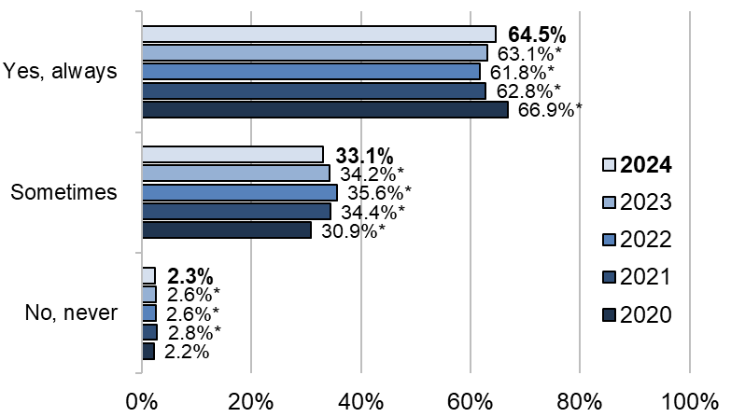

An asterisk indicates a statistically significant difference when compared to the 2024 results.
Answered by all. Respondents who stated they did not need attention have been excluded.
Total number of respondents: 65,926 (2020), 56,132 (2021), 56,138 (2022), 57,369 (2023), 56,490 (2024)

While the proportion of respondents who felt that they ‘always’ understood answers to questions they asked nurses (73%) has stayed fairly consistent with previous years (2023, 72.5%; 2022, 73.3%), it remains lower than in it was in 2020 (77.4%), and analysis on the most positive response option indicates a downward trend for this question.

In the most recent data, approximately three-quarters (73.3%) reported that they always they ‘always’ understood the answers they received from doctors – a statistically significant increase from 2023 (72.2%), though still notably lower than the 2020 figure of 75.4%.

Respondents’ confidence and trust in both doctors and nurses remains high, with 80.1% and 78.3% saying that they ‘always’ had confidence and trust in the doctors and nurses treating them, respectively (compared with 80.2% and 77.8% in 2023). However, analysis of the most positive response option indicates a downward trend for both questions since 2020.

As discussed at the beginning of this results section, several respondent subgroups were more likely to report a worse experience of having confidence and trust in the doctors and nurses treating them. In addition to those already discussed, people aged 16 to 50, those with ‘another long-term condition’, or patients who had stayed in hospital for 2 nights or more were more likely to report poorer-than-average experiences in this area.

Furthermore, respondents whose treatment type was a medical case were less likely to have confidence and trust in the doctors treating them, and those who were categorised into the 8th, 9th, or 10th (least deprived) IMD decile were less likely to have confidence and trust in the nurses treating them.

Of the respondents who said that they ‘always’ had confidence and trust in the doctors treating them 93.7% said that they ‘always’ understood doctors’ responses to their questions. Similarly, 93.4% of the respondents who said that they ‘always’ had confidence and trust in the nurses treating them said that they ‘always’ understood nurses’ responses to their questions.

The proportion of respondents who felt that there were ‘always’ enough nurses on duty (57.9%) has increased significantly compared with that in 2023 (55.7%) and 2022 (51.6%). However, it remains significantly lower than in 2020 (62.4%).

3.5. Discharge from hospital and integrated care

3.5.1. Involvement in leaving hospital

Section 91 of the Health and Care Act 2022 states that NHS trusts are required to involve patients and carers in discharge planning. This should happen as soon as is feasible after a hospital begins making any plans relating to discharge.

Just under three-quarters of all respondents felt that staff involved them in decisions about leaving hospital to some extent (34.3%, ‘a great deal’; 37.7%, ‘a fair amount’), while 18.4% felt that they were ‘not very much’ involved, and 9.6% that they were not involved at all (figure 9). Analysis conducted on the most positive response option for this question indicates a downward trend since 2020.

Among respondents who were more likely to have had worse experiences of being involved in decisions about leaving hospital were people who were categorised into the 8th, 9th, and 10th (least deprived) IMD deciles, aged over 80, or those with autism.
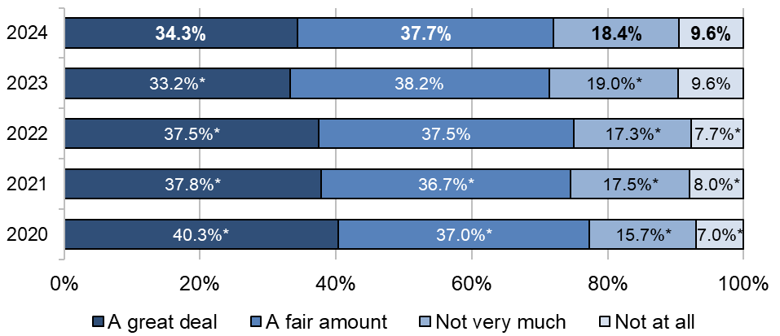
Figure 9: Q35. To what extent did hospital staff involve you in decisions about leaving the hospital?

An asterisk indicates a statistically significant difference when compared to the 2024 results.
Answered by all. Respondents who stated they did not want to be involved in decisions have been excluded.
Total number of respondents: 70,465 (2020), 59,920 (2021), 60,343 (2022), 60,689 (2023) 59,633 (2024)

Less than two-thirds of respondents felt that staff involved their family or carers in decisions about them leaving hospital (28.9%, ‘a great deal’; 31.2%, ‘a fair amount’), while 18% felt that they were ‘not very much’ involved, and around 1 in 5 (21.9%) that they were not involved at all.

Half (48.9%) of all respondents said that they were ‘definitely’ given enough notice before leaving hospital, compared with 47.6% in 2023, showing statistically significant improvement. A further 37.4% felt that they were given enough notice ‘to some extent’ (compared with 37.8% in 2023), while the proportion who said that they were not given enough notice (13.7%) has decreased by 1 percentage point compared with the proportion of all respondents who felt the same in 2023 (14.7%).

3.5.2. Onward care and treatment

Just over 1 in 5 (22.8%) respondents said that they were not given any information about what they should or should not do after leaving hospital. This is a statistically significant improvement when compared to 2023 (24.4%).Of those who did receive information about what they should or should not do after leaving hospital, most felt that they understood the information they had received to some extent (69.7%, ‘very well’; 27.7%, ‘fairly well’).

NICE guidance on involving patients in decisions about prescribed medicines and supporting adherence states that patients should be fully informed about any medicines they need to take, including information about the purpose of the medicine, its expected outcome, its potential side effects, and how to take the medicine.

Half (50.6%) of all respondents said that they were given an explanation of the purpose of the medicine they were to take at home, with 2 in 5 (41.3%) being given an explanation of how to take the medicine, a third (33.6%) being given written information about their medicine, and 1 in 5 (19.9%) being given an explanation on the side effects of their medicine. Results show statistically significant improvement across all of these questions. Around 1 in 10 (11.9%) were given medicine but no information (figure 10).

Figure 10: Q41. Thinking about any medicine you were to take at home, were you given any of the following?
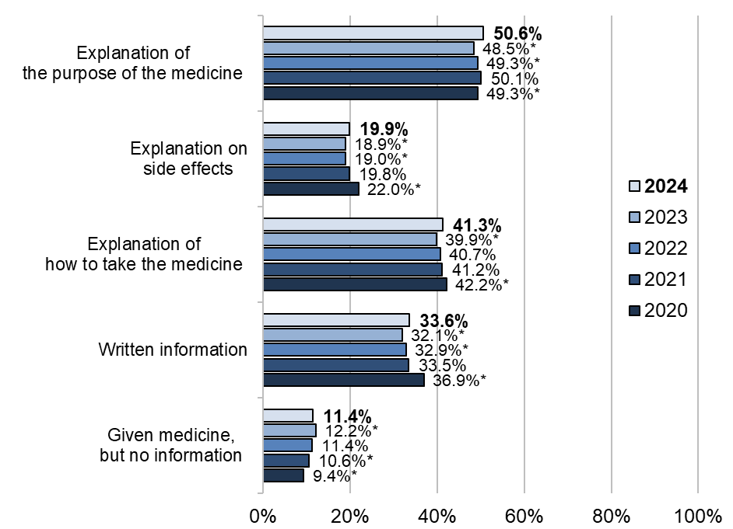

An asterisk indicates a statistically significant difference when compared to the 2024 results.
Answered by all. Multiple response question: percentages might sum to more than 100.
Total number of respondents: 70,814 (2020), 60,004 (2021), 60,117 (2022), 61,055 (2023), 60,071 (2024)

Integrated care aims to provide coordinated support across services, enabling patients to receive care and treatment for 1 or more conditions without unnecessary delays or gaps in information. In an integrated care system, patients should know what services they are likely to need after their discharge from hospital. They should be able to transition between health or social care services without gaps in information or excessive waiting times, to ensure uninterrupted coordination of care.

More than three-quarters (78.5%) of all respondents said that hospital staff discussed whether they would need any further health or social care services after leaving hospital – a significant increase compared the proportion of respondents who said the same in 2023 (76.7%). However, nearly a quarter (23.1%) of respondents who needed adequate support from health or social care services to help them recover or manage their condition after leaving hospital did not receive it.

3.5.3. Virtual wards

The 10 Year Health Plan for England commits to expanding virtual ward and hospital at home programmes as part of the general shift away from acute healthcare settings to more community settings.

Virtual wards (‘hospital at home’) enable people to receive hospital-level care and treatment where they live. NHS England defines virtual wards as a technology-enabled alternative to NHS bedded care, designed to reduce the burden on frontline staff and improve patient outcomes. This includes both pre-hospital models (‘step-up care’), where patients are referred to virtual wards through community routes, and post-hospital models ( ‘step-down care’), where they are referred upon early discharge from hospital. Due to the sampling criteria for the Adult Inpatient survey, all respondents who were admitted onto a virtual ward were admitted through the step-down approach.

Almost 1 in 10 (9.9%) respondents were admitted onto a virtual ward once they had left hospital. Of these respondents, 54.7% said that hospital staff ‘definitely’ gave them information about the risks and benefits of continuing their treatment on a virtual ward. A majority (60%) said that they were given a complete explanation of the care and treatment they would receive while on a virtual ward (figure 11).

Figure 11: Q34: Were you given enough information about the care and treatment you would receive while on a virtual ward?
Answered by all respondents who were admitted onto a virtual ward.
Total number of respondents: 4,949 (2024)

Most (87.8%) respondents who were admitted onto a virtual ward said that hospital staff discussed with them whether they would need any additional equipment in their home, or any changes to their home, after leaving hospital. Of the respondents who were admitted onto a virtual ward, 57.1% said that they ‘definitely’ knew what would happen next with regard to their care, and more than 4 in 5 (83.3%) said that hospital staff told them who to contact if they were worried about their condition or treatment after they left hospital.

3.6. Subgroup analysis

The Equality Act 2010 requires that public bodies have due regard to eliminate discrimination, and to advance equality of opportunity by fostering good relations between people who share certain protected characteristics and those who do not. The protected characteristics are age, disability, gender reassignment, marriage and civil partnership, pregnancy and maternity, race, religion or belief, sex, and sexual orientation. Under the Act, the NHS has a legal duty to promote equality, alongside its commitment to address health inequalities as required by the Health and Social Care Act 2012.

We used a mixed effects model to compare how different groups of people using inpatient services rated their experiences. By analysing the data, we were able to see how people’s experiences vary depending on their background and the care they received – highlighting possible inequalities.

While controlling for other characteristics, subgroup analysis compares the average probability that different subgroups of people using inpatient services select the most positive response to a survey question. The subgroups used in this analysis included:
- age
- sex
- gender
- sexual orientation
- ethnicity
- religion
- route of admission
- length of stay
- medical or surgical treatment type
- diagnosis (ICD-10 chapter codes – see Appendix G)
- frailty
- IMD decile
- disability
- long-term condition.

A new classification of International Statistical Classification of Diseases and Related Health Problems (ICD) chapter codes, ‘ICD-11’, was published in June 2018. As of November 2023 (the sample month for the survey), these new codes have not been universally adopted by participating NHS trusts. Consequently, ICD-10 codes are used to report the results of the 2024 Adult Inpatient Survey, and for computing the subgroup results.

The questions used in the analysis were:
- Q5. How long do you feel you had to wait to get to a bed on a ward, after you arrived at the hospital?
- Q12. Did you get enough help from staff to wash or keep yourself clean?
- Q13. If you brought medication with you to hospital, were you able to take it when you needed to?
- Q14. Did you get enough help from staff to eat your meals?
- Q16. During your time in hospital, did you get enough to drink?
- Q18. Did you have confidence and trust in the doctors treating you?
- Q21. Did you have confidence and trust in the nurses treating you?
- Q24. Thinking about your care and treatment, were you told something by a member of staff that was different to what you had been told by another member of staff?
- Q25. To what extent did staff looking after you involve you in decisions about your care and treatment?
- Q27. Did you feel able to talk to members of hospital staff about your worries and fears?
- Q29. Do you think the hospital staff did everything they could to help control your pain?
- Q30. Were you able to get a member of staff to help you when you needed attention?
- Q35. To what extent did staff involve you in decisions about you leaving hospital?
- Q44. Did hospital staff discuss with you whether you may need any further health or social care services after leaving hospital?
- Q45. After leaving hospital, did you get enough support from health or social care services to help you recover or manage your condition?
- Q46. Overall, did you feel you were treated with kindness and compassion while you were in the hospital?
- Q47. Overall, did you feel you were treated with respect and dignity while you were in the hospital?
- Q48. Overall, how was your experience while you were in the hospital?

Please see Appendix H, an external appendix published on the CQC website, for more details on the methodology used to carry out the analysis, and the full result charts.

The following tables illustrate the findings of the subgroup analysis. For each question, findings that are significantly above (marked ‘B’) or below (marked ‘W’) the average probability are shown for each subgroup category. Please note, no significant results were found in relation to whether a person’s gender matched their sex assigned at birth, so this classification has been excluded from the summary below.

Intersex has been excluded from subgroup table due to low response numbers.

4. Inpatient care policy

This section summarises some of the main policy, standards and guidelines relating to the care of adults admitted to hospital as inpatients in England.

Please note, this section outlines policy and guidance relevant to the sampling period for this survey (November 2024), so it may not reference newer policy published since this period.

4.1. Waiting for elective care

Lord Darzi's report on the state of the National Health Service in England highlights that in almost all NHS services, performance on access to care has declined with long waits having been normalised across the NHS, resulting in declining public satisfaction. The House of Commons Library’s NHS key statistics: England shows that waiting lists for elective care increased in most years since 2012 and have increased faster since 2020.

The NHS Constitution sets a standard that 92% of people waiting for elective treatment should wait no longer than 18 weeks from the day of receipt of a referral letter or when an appointment is booked through the NHS e-Referral Service. For urgent referrals the maximum waiting time target is 2 weeks. The commitments outlined in The 10 Year Health Plan for England, published in July 2025, include restoring of the standard of 92% of patients beginning elective treatment within 18 weeks.
NHS England’s 2024/25 priorities and operational planning guidance included a commitment to eliminate waits of over 65 weeks for elective care as soon as possible and by September 2024 at the latest (except where patients choose to wait longer or in specific specialties). NHS England’s Elective Reform Plan, published in January 2025, set out standards to eliminate waits of over 65 weeks by March 2024.

Prior to the pandemic, in February 2020, there were 4.42 million people waiting for treatment. In November 2024 (the sample period for the 2024 Adult Inpatient Survey), 7.48 million people were waiting for treatment, compared to 7.61 the previous year. As some people may be on the waiting list for multiple conditions, this equates to 6.28 million unique patients waiting in November 2024.

NHS England’s Consultant-led Referral to Treatment Waiting Times Data show that in November 2024 the percentage of people waiting for elective treatment who waited less than 18 weeks was 59.2%, with the median wait time being 14 weeks.

As per the National elective access policy, ICBs are responsible for ensuring all patients are aware of their right to treatment at an alternative provider and the support available to them in the event that their RTT wait goes beyond 18 weeks or is likely to. In this instance ICBs must take all reasonable steps to offer the patient a suitable alternative provider(s) that can see or treat them more quickly than the provider to which they were referred.

NHS England’s Hospital Admitted Patient Care Activity data shows the numbers of patient admissions have continued to steadily increase overtime since 2008-09, except for 2020-21 where they reduced significantly during the Covid-19 pandemic. Data published in September 2024, showed that the number of ‘finished admission episodes’ (FAEs) for 2023-24 reached 17.6 million, exceeding pre-pandemic levels for the first time. NHS England Digital’s Provisional Monthly Hospital Episode Statistics for Admitted Patient Care, Outpatient and Accident and Emergency data showed that in 2024-25 the number of FAEs was 18.3 million.

The Care Quality Commission’s (CQC) state of health care and adult social care in England 2023/24 notes that the overall performance of services to meet the need for care is below the expected standard, and in some cases getting worse.

One of the most commonly measured patient waiting times in the NHS is the waiting time to access a diagnostic service. The NHS Constitution pledges that patients should wait less than 6 weeks for a diagnostic test from the time that the request has been sent. NHS England’s 2024/25 priorities and operational planning guidance included an objective to increase the percentage of patients that receive a diagnostic test within six weeks in line with the March 2025 ambition of 95%. As of the end of November 2024, the number of patients waiting 6 weeks or more from referral for one of the 15 key diagnostic tests was 19.9% (321,795).

Performance for urgent admissions has also continued to be below the expected standard. The four-hour standard is a pledge in the NHS Constitution that at least 95% of patients attending A&E should be admitted to hospital, transferred to another provider, or discharged within four hours. At a national level, the standard of 95% has not been met annually since 2013-14. According to data published by NHS Digital, 72.1% of patient attendances in England spent 4 hours or less in A&E in the financial year 2023-24.

4.2. Delayed transfers of care and hospital discharge

Overnight bed occupancy is defined by the National Institute for Health and Care Excellence (NICE) as the proportion of available (open and staffed) beds that were occupied at midnight (measured daily) on every bedded ward. The Nuffield Trust argues that high levels of hospital bed occupancy are an important indicator of a health system under pressure.

NICE advises a “pragmatic maximum” benchmark for bed occupancy of 90%. According to figures published by NHS England overnight bed occupancy in England in quarter three, 2024-25, (which includes the Adult Inpatient survey’s sample month of November 2024) was 87.3%.

According to research by the King’s Fund, the number of hospital beds in England has halved over the past 30 years, primarily due to medical advances meaning shorter stays in hospital and a general national policy shift towards providing care outside of hospital. However, the King’s Fund argues that more recently there has been growing concern that this trend has gone too far and now there aren’t enough hospital beds. The most recent data from the OECD (Organisation for Economic Co-operation and Development) shows that in 2022 there was an average of 2.4 beds for every 1,000 people in the UK, while many in EU nations it was 5 beds.

The Care Quality Commission’s (CQC) state of health care and adult social care in England 2023/24 notes that since the beginning of 2022, more than 1 in 10 occupied beds are being used by someone whose discharge was delayed. Data from NHS England’s acute daily discharge situation report (sitrep) shows that in November 2024, a daily average of over 12,000 patients in England who no longer met the criteria to reside were not discharged. This equated to over 500,000 additional “bed days” for patients with length of stay of 7 days or over.

Lord Darzi's report on the state of the National Health Service in England notes that the overall progress in reducing length of stay masks significant variation by specialty, possibly reflecting a shift to day cases, which means that only the most complex patients stay in hospital.

The discharge to assess (D2A) model for managing transfers of care was introduced in NHS trusts in England in 2016. It aims to discharge patients from hospital as soon as they no longer need acute care but who may still need care services – providing them with short-term, funded support in their own home or another community setting during a period of recovery and reablement. The update to hospital discharge and community support guidance in January 2024 has clarified the discharge to assess process, sets out the four discharge pathways under this model, and now outlines that NHS bodies and local authorities should agree the discharge models that best meet local needs.

4.3. Virtual wards

Virtual wards allow patients to safely and conveniently receive acute care at their usual place of residence, including care homes. NHS England’s national guidance refers to these types of services as ‘virtual wards’, but local services can decide if they wish to be known as a ‘virtual ward’ or a ‘hospital at home’ (HaH) service.

Research by the Health Foundation has found that virtual wards across England are diverse, with different patient populations, referral pathways, technology use and staffing models. Local areas continue to develop a wide variety of virtual ward models that operate in different ways, accounting for the local population, service and workforce context.

The Virtual wards operational framework clarifies the expectations of virtual wards and how they should be developed over time to maximise benefits for patients and the NHS. This framework supports consistency across the NHS and the relevant goals in line with the 2024/25 priorities and operational planning guidance: maintaining virtual ward capacity and optimising occupancy so it is consistently above 80%. Figures published by NHS England show that there were 12,739 virtual ward ‘beds’ in England as of November 2024, with an occupancy rate of 77%.

The 10 Year Health Plan for England sets out the government’s strategy to shift NHS services to more community-based and technology-driven healthcare with a focus on prevention to ensure the future sustainability of the NHS. In the first 3 years of the Plan, virtual ward and hospital at home programmes will be expanded in conjunction with the National Institute for Health and Care Excellence’s (NICE) digital programme to consider more medical-grade wearables.

4.4. Health inequalities

Tackling disparities in access to services, patient experience and health care outcomes is an enduring mission for the NHS, and one of the 4 key aims for ICSs.
This aim was reflected in NHS England’s 2024/25 priorities and operational planning guidance which introduced a comprehensive and evidence-based approach, with a focus on the Core20PLUS5 – a target population composed of the most deprived 20% of the national population as identified by the national Index of Multiple Deprivation (IMD), groups that share protected characteristics as defined by the Equality Act 2010, and inclusion health groups – and five focus clinical areas requiring accelerated improvement: maternity, severe mental illness, chronic respiratory disease, early cancer diagnosis, and hypertension case-finding and optimal management and lipid optimal management.

The 2023 King’s Fund report Tackling Health Inequalities On NHS Waiting Lists considered how structural, economic and social factors were in contributing to the inequalities in the length of time people faced wait for NHS planned hospital care – such as hip or knee operations. The report highlighted that an approach to managing waiting lists based solely on treating people with similar clinical needs equally risks overlooking other influences that might widen inequalities for example appointments being difficult to attend because of caring responsibilities or existing disabilities. These causes of inequalities are likely to have different impacts in different parts of England and for different specialties which means that any action to remedy need to be carefully tailored locally.

New data published by NHS England show patients in the poorest communities and those from an Asian or Asian British background are more likely to be waiting longer than 18 weeks than any other group.

Tackling health inequalities is a focus of the NHS 10 Year Health Plan, through reform leading to more patient-centred services, redistributing power to patients and communities through embedding equity into neighbourhood community care models. Alongside this, data and AI will drive quality improvements and transparency, and financial flows will be aligned with need and patient experience.
Guidance on the preparation of integrated care strategies highlights that integrated care partnerships must involve people who live and work in the local area when preparing integrated care strategies. This is supported by the 2024 NHS Providers report Co-production and engagement with communities as a solution to reducing health inequalities, which highlights how co-production can increase understanding of why particular groups, face barriers in accessing healthcare services, helping trusts and providers to better understand and overcome inequalities.

NHS England’s equality objectives and updated targets for 2024/25 and 2025/26 outline ambitions to improve access and reduce communication barriers experienced by individuals and groups of people who need NHS services and ensure that the equality objectives for NHS England address the relevant statutory functions, duties, powers and responsibilities of NHS England created by the Health and Care Act 2022.

Tackling inequalities to make sure everyone has good quality care, as well as equal access, experience and outcomes from health and social care services is a strategic priority in CQC’s strategy from 2021.
In line with this strategy, CQC published equality objectives with the goal of ensuring everyone has equal access, experience and outcomes from health and social care services. CQC do not set the priorities for reducing inequalities, but work closely with other bodies who have these roles, and as an independent regulator, will take appropriate regulatory action or speak up where care isn’t good enough for any groups of people.
There is also increasing evidence of the link between workforce equality and good quality care. CQC has commissioned research into the causes and effects of workplace discrimination in health and adult social care considering systemic, institutional and interpersonal racism and other forms of discrimination. The research also considers approaches to addressing this for providers and CQC as the regulator.

4.5. Staffing levels

Lord Darzi's report on the state of the National Health Service in England highlights that the hospital workforce has expanded very significantly in recent years, rising 17% between 2019 and 2023.

Data published by NHS Digital shows the number of HCHS staff working in NHS Trusts and other core organisations in England (excluding primary care staff). The general trend has seen a steady increase in the number of HCHS staff since mid-2013 with the most recent NHS employment figures showing over 1.5 million hospital and community staff in England as of November 2024 (the sampling month for this survey), an increase of 3% (45,277) compared to November 2023.

NHS data for quarter three of 2024-35 showed vacancy rates of 6.4% for nursing staff and 5.1% for medical staff, compared to 8.3% and 5.8% respectively for the same period the previous year. However, vacancies vary by region, from an overall vacancy rate of 8.3% in London to a low of 5.4% in the North East and Yorkshire.

In the results from the most recent NHS Staff Survey, 47.3% felt able to meet all the conflicting demands on their time at work, while 30% of staff reported feeling burnt out because of their work, and just 34% felt there were enough staff at their organisation to do their job properly.

NHS England’s 2024/25 priorities and operational planning guidance, outlined plans to improve the working lives of all staff and increase staff retention and attendance through such measures as the implementation of the People Promise retention interventions, increasing choice and flexibility in rotas, reducing duplicative inductions and payroll errors, and providing sufficient clinical placements and apprenticeship pathways.

The Care Quality Commission’s (CQC) state of health care and adult social care in England 2023/24 found that most ICSs saw the importance of reducing their spend on temporary staff, and they have clear plans for improving recruitment, as well as staff retention.

Monthly data published by NHS Digital shows the sickness absence rate for acute organisations in November 2024 was 5.29% compared to 5.19% in November 2023. The overall sickness absence rate for England was 5.43%, slightly higher in November 2023 (5.3%). As with previous years, anxiety/stress/depression/other psychiatric illnesses was the most reported reason for sickness, accounting for over 630,300 full time equivalent days lost and 26.6% of all sickness absence in November 2024.

Appendix A: Survey methodology

This appendix covers aspects of survey methodology including questionnaire design, sampling, fieldwork and analysis. For more detailed information and for information on data limitations, please see the Quality and methodology report.

Questionnaire design

Before each survey, its questions are reviewed to ensure that the questionnaire is up-to-date and reflects current policy and practice. This work helps us to ensure that that the questions are as useful and relevant as possible for people who use services and for other stakeholders who use the survey data in their work. More information on how survey stakeholders use the data is provided in Appendix D.

Wherever possible, questions remain the same over time so that change can be measured. However, the transition from a paper-based to a mixed-mode data collection methodology for the 2020 Adult Inpatient Survey necessitated a break in trends. The 2020 questionnaire underwent a comprehensive review in response to these large-scale changes. Full details of this change are available in the survey development report for the 2020 survey. Minimal changes were made to the 2024 Adult Inpatient Survey. All changes are detailed in the Survey Development Report.

Comparability with previous years

Results from the 2024 survey are comparable with those from the 2023, 2022, 2021, and 2020 Adult Inpatient Surveys only. As large-scale changes were made to the 2020 survey, it is not comparable with surveys from previous years.

This year, if a question has at least 5 years of data and it evaluates care, trend analysis was conducted on the most positive (“top box”) response to identify significant change over time. The trend analysis of the last 5 years can be interpreted in conjunction with the statistically significant test results detailed in the National Tables document:

- An upward trend combined with a statistically significant increase in top-box responses between survey years suggests that there is continuing improvement.

- An upward trend, combined with no statistically significant differences in top-box responses between survey years, suggests that there was historical improvement, but no recent change has occurred.

- An upward trend, combined with a statistically significant decrease in top-box responses between survey years, suggests that there was historical improvement followed by emerging concerns in more recent results.

- No overall trend, combined with a statistically significant increase in top-box responses between survey years, suggests that there was historically no clear directional change, but recent improvement has occurred.

- No trend and no statistically significant differences in top-box responses between survey years indicate no clear directional change.

- No trend, combined with a statistically significant decrease in top-box responses between survey years, suggests historically stable perceptions with emerging concerns.

- A downward trend, along with a statistically significant decrease in top-box responses between survey years, indicates ongoing concerns.

- A downward trend with no statistically significant difference in top-box responses between survey years suggests persistent concerns with no recent change.

- A downward trend, coupled with a statistically significant increase in top-box responses between survey years, indicates historical concerns with signs of recent improvement.

The response rate to the 2024 survey decreased slightly compared with the previous year (40.8% compared with 41.7% in 2023). The demographic profiles for the 2024 survey and the previous 4 iterations can be found in the National Tables document, which is published on the Care Quality Commission’s (CQC) website, and the Adult Inpatient Survey 2024 webpage on the NHS Surveys website.

Survey methods

The 2024 Adult Inpatient Survey was conducted using both online and postal questionnaires. All relevant survey materials were redeveloped for the 2020 survey, drawing on best practice in social research to reflect the mixed-mode approach. These materials were then carried forward to the 2024 survey.

Patients were sent 3 letters containing a URL for the online survey, and 2 SMS reminders with a personalised URL that took them directly into the online survey without the need for a login to encourage online completion. QR codes were also included in the invitation letters, allowing respondents to conveniently access the online survey via their smartphones. SMS reminders were sent shortly (3 days) after the letters.

All participants received a postal questionnaire with their third letter. Those aged 80 and over were sent a postal questionnaire with both the first and third letters.

Fieldwork for the survey (the time during which questionnaires were sent out and returned) took place between January and April 2025. The length of fieldwork varied by trust, depending on when each trust approved its sample of participants. All fieldwork was completed within 14 weeks, with an average duration of 13 weeks and a minimum of 11 weeks.
To adhere to best practice in accessibility, the questionnaire was made available in multiple accessible formats. The online survey was translated into 9 non-English languages and British Sign Language. Additionally, participants were able to change the font size and background colour of the online survey, and it was tested to ensure screen reader compatibility. A paper Braille, large-print, and easy-read questionnaire were available on request.

Accessibility formats | Number of requests received
Non-English online completes | 260
BSL online completes | 16
Braille/large print requests | 24
Easy read requests | 4
Phone calls | 5,447
Emails | 866
Telephone assisted completes | 166
Telephone calls requiring translator | 1

Sampling

Trusts drew a sample of 1,250 patients aged 16 or over who had stayed at least 1 night in hospital during November 2024. Trusts were required to include every consecutive discharge since 30 November until they had reached the 1,250 target. A small number of trusts with a smaller patient cohort throughout (such as specialist trusts) were required to sample back to earlier months.

Certain groups of patients were excluded before the trusts drew their sample, including:
- Patients who had died.
- Children or young people who were under 16 years old at the time of drawing their sample.
- Women using obstetrics or maternity services, including those who had had a spontaneous miscarriage.
- Patients who had been admitted for planned termination of pregnancy.
- Psychiatry patients (who received treatment for a mental health condition).
- Day case patients (who arrived and left hospital on the same day).
- Private patients (non-NHS service users).
- NHS patients who were being treated at private hospitals.
- Any patients who were known to be inpatients at the time samples were drawn.
- Patients without a UK postal address or patients whose address was unusable because it was incomplete.
- Patients who had opted out of having their details used for anything except clinical care.

No trusts were excluded from analysis due to sampling errors.

The sample size was sufficient to allow analysis of results at both the individual trust-level and site-level. Full details of the sampling are available in the survey’s sampling instructions.

Data cleaning

‘Data cleaning’ refers to the editing processes applied to survey data after completion, entry, and collation. This is carried out to ensure that the data is of high quality, and is comparable across trusts. For further information please refer to the data cleaning guidance.

Weighting

The data presented in this report has been weighted in 2 ways:

- ‘Trust weight’ aims to ensure that each trust has an equal influence on England’s results. As some trusts have higher response rates than others, they account for a larger share of respondents in the overall population for England.
- ‘Population weight’ adjusts each individual's response to ensure representativeness of the trust’s own population, based on the initial eligible sample. This involves weighting by variables known to influence response patterns: age group, sex, and route of admission (planned or emergency).

Both weighting components are then multiplied together to produce a single combined weight for the data tables that underpin the analysis. Demographic questions (questions 51 to 59) are excluded from weighting, as presenting unadjusted percentages provides a more accurate reflection of the respondent profile.

Rounding

The percentages shown in the results are rounded to the nearest whole number, so the values given for any question will not always add up to 100%.

Rounding up or down might make differences between survey years appear bigger or smaller than they are.

Statistical significance

Statistical tests were carried out on the data to determine whether there had been any statistically significant changes in the results for 2024 compared with the results for 2023, 2022, 2021, and 2020.

A ‘t-test’ set to 95% significance was used to compare data between the survey years. A statistically significant difference means there is a chance of 5% or less that the result could have been achieved without an underlying change

In other cases, though there might be a visible change in the results between 2024 and previous years, it is not significant. There are several reasons for this, such as:
- Rounding figures up or down makes a difference appear larger or smaller than it actually is.
- The larger the sample size, the more likely it is that findings will be statistically significant, giving us greater confidence in the results – while with smaller sample sizes, only very large differences are likely to reach statistical significance.

The amount of variation also influences whether a difference is statistically significant. In this context, ‘variation’ refers to differences in how people respond to a question. When variance is high, differences between groups are less likely to reach statistical significance.

The Quality and methodology report contains relevant background information to help readers to understand the survey data, including response rates, sampling errors, and data limitations.

Appendix B: Other sources of information related to survey results

This section summarises other sources of data related to inpatient care in England. Please note that, as they do not measure the experiences of people using services, these data sources are not directly comparable with the survey findings presented in this report.

NHS Outcomes Framework indicators

The NHS Outcomes Framework (NHS OF) aims to drive transparency, quality improvement, and outcome measurement throughout the NHS. The OF provides national accountability for the outcomes that the NHS delivers.

The framework sets out the national outcome goals that the Secretary of State uses to monitor the progress of NHS England. It does not set out how these outcomes should be delivered.

Data from the NHS Patient Survey Programme is used to monitor Domain 4, ‘Ensuring that people have a positive experience of care’. This emphasises the importance of providing a positive experience of care for patients, people who use services, and carers.

Quality standard for patient experience in adult NHS services

The National Institute for Health and Care Excellence sets out a quality standard that outlines 6 quality statements about patient experience. The standard aims to provide the NHS with clear commissioning guidance on the key components of good patient experience. It provides evidence-based statements for commissioners, forming the foundation for an NHS cultural shift toward a more patient-centred service.

Hospital Episode Statistics data

NHS Digital’s Hospital Episode Statistics is a data warehouse containing details of all admissions, outpatient appointments, and A&E attendances at NHS hospitals in England.

Its Admitted Patient Care publication contains provider-level analysis of Adult Critical Care activity and hospital episodes filtered by patient demographics, admission methods, waiting times, and more. It also describes hospital performance in England.

Patient experience

NHS England publishes monthly results from its Friends and Family Test. This is a single-question feedback tool that asks people whether they would recommend the service they have received to friends and family who need similar treatment or care.

Staffing

NHS Digital publishes monthly NHS workforce statistics on its website. Please note this data covers all trust types, such as acute and community trusts, as well as mental health care providers.

Appendix C: Comparisons with other data

Other countries have also conducted inpatient surveys, reflecting people’s experiences within different healthcare systems, guided by varying policies and practices. Direct comparisons with the survey that this report relates to are not recommended due to differences in methodology, question design, and survey timing. In addition, variations in phrasing, scale lengths, and reporting formats – including rating types – can influence how people respond.

The Scottish Government’s Inpatient Experience Survey for Scotland was put on hold due to pressures related to the COVID-19 pandemic, and remains on hold at time of writing. The results from the 2018 Inpatient Survey are available on the Scottish Government’s website.

More information on the Inpatient Patient Experience Survey carried out in Northern Ireland is available on the Northern Ireland Department of Health’s website.

At the time of writing, there is no similar survey carried out in Wales.

Ireland

The National Inpatient Experience Survey has been run on an annual basis since 2017 as a joint initiative between the Department of Health, the Health Information and Quality Authority (HIQA) and the Health Service Executive (HSE).

The survey was cancelled in 2020 due to the pandemic and the additional demands placed on the health service during that time. The survey has since been run again, in 2021 and 2022, using similar methodology to that used for CQC’s Adult Inpatient Survey, in that its respondents are sent a questionnaire in the post along with the option to complete the survey online.

The survey was run again in 2024, following an international review in 2023 to ensure that it remained in line with current healthcare system needs and international best practice.

New Zealand

The Adult Hospital Inpatient Experience Survey, which began in 2014, is run by the Health Quality and Safety Commission. Respondents are contacted quarterly by email, SMS, or post, in that priority order. The survey covers 4 key domains: communication, partnership, co-ordination, and physical and emotional needs. Results are available at a national and District Health Board-level.

Appendix D: Main uses of the survey data

This appendix lists known users of data from the Adult Inpatient Survey, and how they use the data.

Care Quality Commission

CQC will use results from the survey to build an understanding of the risk and quality of services, and the organisation of care across an area. Where survey findings provide evidence of a change to the level of risk or quality in a service, provider, or system, CQC will use the results alongside other sources of data on people’s experiences to inform targeted assessment activities.

CQC survey results are reviewed alongside other data sources before each provider inspection that we carry out. Key themes and findings from the survey, which might warrant further follow up with providers, are highlighted to the inspection teams.

For more information see our ‘About us’ webpage.

Department of Health and Social Care

The government measures progress towards improving people’s experiences of inpatient care through Domain 4 of the NHS OF, ‘ensuring people have a positive experience of care’. The framework sets out the outcomes and corresponding indicators that the Department of Health and Social Care uses to hold NHS England to account for improvements in health outcomes.

The indicators are drawn from trust-level survey data that has been standardised and scored, similar to the format used in CQC’s benchmark reports. This differs from the national-level percentages shown in this report, which reflect the proportion of respondents across England but are not used to calculate these indicators.

More information is available on the NHS Digital website.

NHS England

NHS England is a key user of data from the NHS Patient Survey Programme. Listening to patients’ experiences of their care plays a crucial part in delivering services that are safe, effective, and continuously improving. Data from the programme helps NHS England to understand patients’ experiences of the services that they are receiving from acute and community settings.

Data from the Adult Inpatient survey is used within the NHS oversight framework 2025/26 to monitor performance. This 1-year framework sets out how NHS England will assess providers and ICBs, alongside a range of agreed delivery metrics, promoting improvement and helping NHS England to quickly identify where organisations need support.

NHS trusts and commissioners

NHS trusts and commissioning organisations use the survey results to identify areas for improvement and implement changes that enhance the experiences of people using their services. Each participating trust receives a benchmark report, which provides it with a score for each evaluative question in the survey and an outline of how this compares with all trusts.

Results are analysed at the integrated care system level to generate scores for each system.

Data from CQC’s patient surveys is added to the Patient Experience Library’s surveys tracker, which consolidates all survey data and benchmark reports in 1 place, with cross-referencing across common themes such as cleanliness, waiting times, and other aspects of patient experience. A summary of each survey’s results appears in the Library’s annual Patient Experience in England report, which is disseminated to around 2,000 individuals and organisations with an interest and involvement in patient experience.

The tracker was developed in response to discussions with heads of NHS England’s Patient Experience Network, whose members value it as a vital tool for enabling Boards and senior Trust management to quickly and easily access key components of patient experience evidence.

It is open access and can be used by patient groups, health charities, policy bodies, and researchers.

Appendix E: Revisions and corrections

CQC’s revisions and corrections policy sets out how we will respond if an error is identified in any survey, and it becomes necessary to correct published data or reports.

Data from the NHS Patient Survey Programme is not subject to any scheduled revisions as it captures people’s views on their experiences of care at a specific point in time. All new survey results are published on the NHS Surveys website accordingly, and results from previous iterations of the same survey are not revised.

Appendix F: Further information and feedback

Further information

This report, together with its trust-level results, is available on CQC’s website. The website also contains a Technical document that describes the methodology for analysing trust-level results, and a Quality and methodology report, which provides information about the survey’s development and approach.

All survey reports, guidance materials and related documents are available on the NHS Surveys website. These resources include detailed information on the survey methodology, participant communications (such as questionnaires and letters), implementation instructions, and a survey development report.

More information on the NHS Patient Survey Programme, including results from other surveys, and a programme of current and forthcoming surveys, is available on the NHS Surveys website.

Further questions and feedback

This summary has been produced by CQC’s research team. We welcome all feedback on the survey findings and the way in which we have reported the results, particularly from people using services and their representatives, and those providing services. You can contact the research team with any comments, questions, or suggestions about how this publication can be improved.

CQC will review your feedback and use it as appropriate to improve the statistics that we publish across the NHS Patient Survey Programme. If you would like to be involved in consultations, or to receive updates on the NHS Patient Survey Programme, please subscribe through the CQC website.

To make a statutory request for information under legislation such as the General Data Protection Regulation or the Freedom of Information Act 2000, please direct your enquiry to information.access@cqc.org.uk.

For more information see the government’s guidance on how to make a request for information.

Accredited Official Statistics status

Being a provider of Accredited Official Statistics means that our statistics are official, and meet the highest standards of trustworthiness, quality, and public value.

All official statistics should comply with all aspects of the Code of Practice for Statistics. They are awarded Accredited Official Statistics status following an assessment by the authority’s regulatory arm. The Authority considers whether the statistics meet the highest standards of Code compliance, including the value they add to public decisions and debate.

You are welcome to contact us directly with any comments about how we meet these standards. Alternatively, you can contact the Office for Statistics Regulation by emailing regulation@statistics.gov.uk, or through the Office for Statistics Regulation’s website.

Appendix G: ICD-10 chapter codes

A new classification of International Statistical Classification of Diseases and Related Health Problems (ICD) chapter codes, ‘ICD-11’, was published in June 2018. This includes 28 chapter codes, whereas the former ICD-10 classification included 22. As of November 2023 (the sample month for the survey), these new codes have not been universally adopted by participating NHS trusts. Consequently, ICD-10 codes are used to report the results of the 2023 Adult Inpatient Survey, and for computing the subgroup results.

The new ICD-11 classification can be found on the World Health Organization’s website. The table below presents the ICD-10 chapter codes.

Chapter code | Disease/Health problem
I | Certain infectious and parasitic diseases
II | Neoplasms
III | Diseases of the blood and blood-forming organs and certain disorders involving the immune mechanism
IV | Endocrine, nutritional and metabolic diseases
V | Mental and behavioural disorders
VI | Diseases of the nervous system
VII | Diseases of the eye and adnexa
VIII | Diseases of the ear and mastoid process
IX | Diseases of the circulatory system
X | Diseases of the respiratory system
XI | Diseases of the digestive system
XII | Diseases of the skin and subcutaneous tissue
XIII | Diseases of the musculoskeletal system and connective tissue
XIV | Diseases of the genitourinary system
XV | Pregnancy, childbirth and the puerperium
XVI | Certain conditions originating in the perinatal period
XVII | Congenital malformations, deformations and chromosomal abnormalities
XVIII | Symptoms, signs and abnormal clinical and laboratory findings, not elsewhere classified
XIX | Injury, poisoning and certain other consequences of external causes
XX | External causes of morbidity and mortality
XXI | Factors influencing health status and contact with health services
XXII | Codes for special purposes

For more information visit the World Health Organization’s website or the ICD-10 user guide.

References

Cases where patients had been admitted to adult inpatient services through a referral are categorised as a planned admissions (referred to as ‘elective’ in this report).
Emergency admissions are cases where patients accessed inpatient care following a visit to an emergency department or an urgent treatment centre. In a small number of these cases, patients could have had a planned admission, but due to the urgent nature of the care needed, admission was re-categorised as an emergency.
We report the ‘adjusted’ response rate. The adjusted base is calculated by subtracting the number of questionnaires returned as undeliverable, or cases where someone had died, from the total number of questionnaires sent out. The adjusted response rate is then calculated by dividing the number of returned useable questionnaires by the adjusted base.
Responses to questions such as “don't know/can’t remember” are not shown and are excluded from percentage calculations. The wording for these responses is designed for when a respondent cannot remember or does not have an opinion.
With this approach, there is a 5% or less chance that the result could have been achieved without an underlying change.
Respondents who indicated that their long-term condition reduces their ability to carry out day-to-day activities either ‘a lot’ or ‘a little’ are defined as disabled for the purpose of this analysis.
Respondents who indicated that they had experienced 2 or 3 of the following in the 12 months preceding their survey participation have been classified as frail: problems with your physical mobility, for example, difficulty getting about your home; two or more falls that have needed medical attention; feeling isolated from others.
Emergency admissions are cases where patients accessed inpatient care following a visit to an emergency department or an urgent treatment centre. In a small number of these cases, patients could have had a planned admission, but due to the urgent nature of the care needed, admission was re-categorised as an emergency.
Cases where patients had been admitted to adult inpatient services through a referral are categorised as a planned admissions (referred to as ‘elective’ in this report).
Respondents who indicated that they had experienced 2 or 3 of the following in the 12 months preceding their survey participation have been classified as frail: problems with your physical mobility, for example, difficulty getting about your home; two or more falls that have needed medical attention; feeling isolated from others.
Deprivation is based on the English indices of deprivation 2019. The Indices are a set of relative measures of deprivation for small areas across England, based on 7 different domains of deprivation.
Respondents who indicated that their long-term condition reduces their ability to carry out day-to-day activities either ‘a lot’ or ‘a little’ are defined as disabled for the purpose of this analysis.
Emergency admissions are cases where patients accessed inpatient care following a visit to an emergency department or an urgent treatment centre. In a small number of these cases, patients could have had a planned admission, but due to the urgent nature of the care needed, admission was re-categorised as an emergency.
Care Quality Commission, Our Public Engagement Strategy 2023 – 2026, 2023
Department of Health and Social Care, NHS Constitution in England, 2012
NHS Institute for Innovation and Improvement, The Patient Experience Book, 2013
NHS England, Domain 4: Ensuring that people have a positive experience of care, 2013
NHS, Guide to NHS waiting times in England, 2019
NHS, Fit for the Future: The 10 Year Health Plan for England, 2025
Royal College of Physicians, Measurement, management and elimination of temporary care environments for patients admitted to hospital, 2025
The Health Foundation, Person-centred care made simple, 2014
Care Quality Commission, Regulation 10: Dignity and respect, 2014
Royal Pharmaceutical Society, Professional guidance on the safe and secure handling of medicines, 2018
NHS, Consent to treatment, 2019
Parliamentary and Health Service Ombudsman, Broken trust: making patient safety more than just a promise, 2023
NICE, Medicines adherence: involving patients in decisions about prescribed medicines and supporting adherence, 2009
NHS England, What are integrated care systems?, 2022
NHS, Fit for the Future: The 10 Year Health Plan for England, 2025
NHS England, What is a virtual ward?, 2021
NHS England, A guide to setting up technology-enabled virtual wards, 2021
Nuffield Trust, Virtual wards and Covid-19: An explainer, 2022
NHS, Guide to NHS waiting times in England, 2019
NHS, Fit for the Future: The 10 Year Health Plan for England, 2025
NHS England, Consultant-led Referral to treatment Waiting Times, 2025
The King’s Fund, Waiting times for elective (non-urgent) treatment: referral to treatment (RTT), 2024
NHS England, National elective access policy, 2025
NHS Digital, Hospital Admitted Patient Care Activity, 2021-22, 2022
Care Quality Commission, The state of health care and adult social care in England 2023/24, 2024
The King’s Fund, Patient waiting times, 2023
NHS England, Diagnostics Waiting Times and Activity, 2025
NHS Digital, Hospital Accident & Emergency Activity, 2023-24, 2024
NICE, Emergency and acute medical care in over 16s: service delivery and organisation. Chapter 39 Bed occupancy, 2018
Nuffield Trust, Hospital bed occupancy, 2024
NICE, Emergency and acute medical care in over 16s: service delivery and organisation. Chapter 39 Bed occupancy, 2018
NHS England, Bed Availability and Occupancy Data – Overnight, 2025
The King’s Fund, The number of hospital beds, 2024
NHS England, Acute daily discharge situation report (sitrep), 2024
NHS England, Virtual wards operational framework, 2024
Health Foundation, Virtual wards: no place like home?, 2024
Nuffield Trust, Virtual wards: the lessons so far and future priorities, 2023
NHS, Fit for the Future: The 10 Year Health Plan for England, 2025
NHS, What are integrated care systems?
NHS England, Waiting List Minimum Data Set (WLMDS) Information, 2025
NHS, Fit for the Future: The 10 Year Health Plan for England, 2025
NHS England, NHS England equality objectives for 2024/25 and 2025/26, 2024
Care Quality Commission, Our equality objectives 2021-2025, 2021
Care Quality Commission, Our equality objectives 2021-2025, 2021
Care Quality Commission, Tackling workforce inequalities in health and adult social care (June 2025), 2025
NHS England, NHS Workforce Statistics, 2024
NHS England, NHS Vacancy Statistics, 2025
NHS Digital, NHS Sickness Absence Rates, November 2024, 2024

